THSPA Region 3 Div 4 Meet
Arp High School Thursday March 5th, 2026

Lifting
  - Begins at 4:15 AM in the Gym
  - Platforms and Flights TBD

Bring with you:
  - Eligibility Form - Signed by your Principal or Superintendent
  - Scholarship Application (Optional) For senior lifters who would like to be considered for a
scholarship to help with college expenses.
  - Check for $35.00 per lifter payable to: Arp ISD Athletics*
*Your school becomes responsible for your lifter(s) entry fee at 4:00 p.m., Monday March 2nd. Please notify me on or before the deadline if your lifters can’t compete or you will be responsible for their entry fee.
*No payment is necessary for alternates.

Alternates
  - If you have lifters ranked in the top 20, bring them with you as there may be no-shows or lifters who do not make weight.

Weigh In
  - Wednesday, March 4th - early weigh in: 5:00 to 6:30 P.M.
  - Thursday, March 5th - weigh in: 1:45 P.M. to 3:15 PM.

Coaches / Judges Meeting
  - 3:45 PM

Admission
  - $5.00 (cash only)

T-shirts

  - Will be available

Supper
  - There will be a meal served for the coaches.
  - Meals for the athletes: Please notify me by e-mail at wess@arpisd.org how many meals you will need.The cost will be $9.00 each. Make checks for athlete’s
meals payable to Arp ISD Athletics. Entry and meal checks can be on one check.
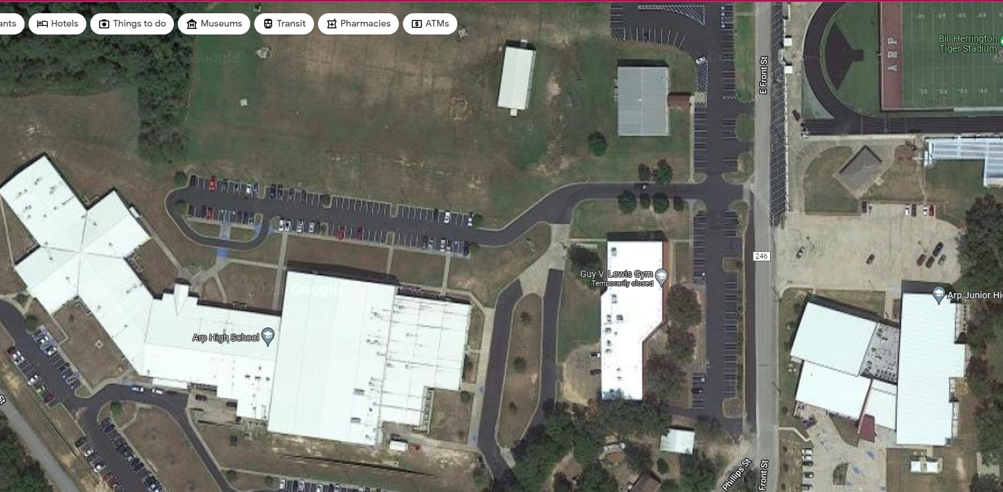

.
Bus/Van Parking
Jr High Gym
Early Weigh –In Thursday
High School Gym
Gym Entrance

